TIMESHEET & LEAVE MANAGEMENT SYSTEM

USECASE DIAGRAMS

Team

Sushma Adepu
Anusha, Bestha
Jyoti Behera
Lakshmi, Thammishetty
Sumanth,Tadikonda

DOCUMENT RELEASE NOTICE
Document Details:

Name | Version No | Description
Use Case Diagrams Document | 0.1 | This document is for Time sheet & Leave Management System of Northeastern Illinois University  which includes the use case diagrams of all the modules.

Revision Details:

Action Taken  (Add/Del/Change) | Preceding Page No | New Page No | Revision Description

Use Case Diagrams – Time sheet & Leave Management System

Module 0 – Student Worker Profile

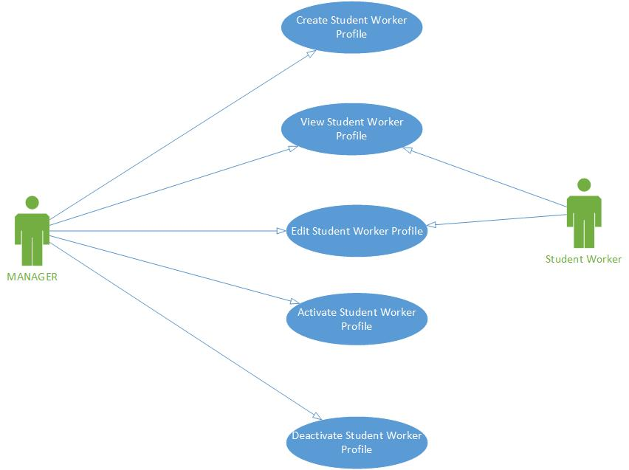

Module 1 – Login

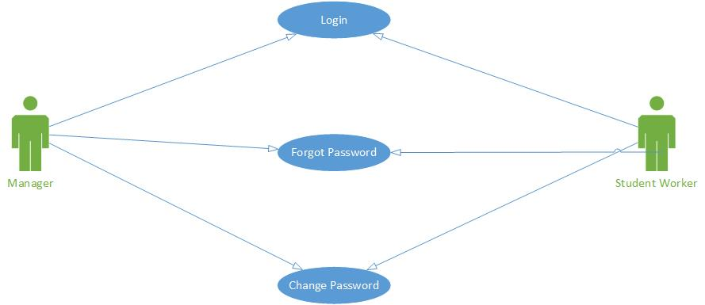

Module2&4- Time sheet Management

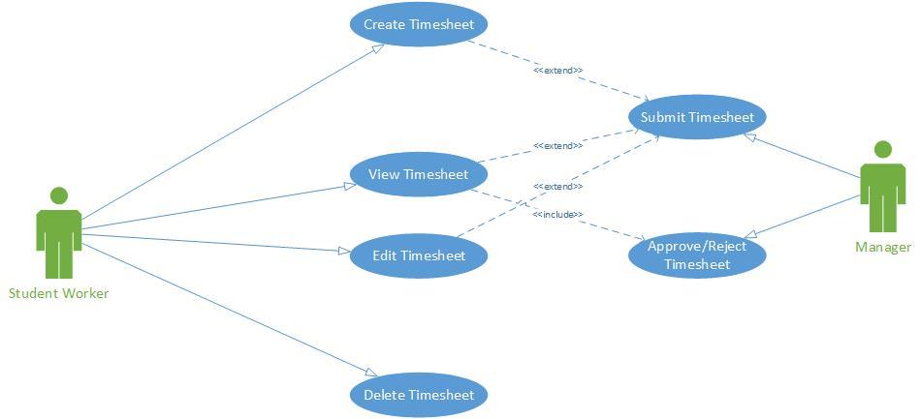

Module3- Leave Management

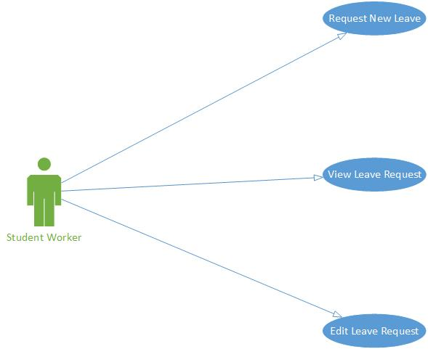

Module5- Leave Request/Approval/Rejection

